Hospital Management System
Student Name
University
Professor’s name
March 7, 2020

Time Table
There are some changes have been made to what we propose in Project Proposal released at the end of the semester on insert date, which are as follows:
- The project plan has been revised to have 2 progresses with final progress instead of 3 progresses with final progress:

Original schedule proposal |  | Current schedule after update
Progress 1 | Feature 1: Schedule management  Feature 2: User registration and authentication  Feature 3: Appointment management | Progress 1 | Feature 1: Schedule management  Feature 2: User registration and authentication  Feature 3: Appointment management
Progress 2 | Feature 4: Patient identification using QR code  Feature 5: Dental care consulting and following up | Progress2 | Feature 4: Patient identification using QR code  Feature 5: Dental care consulting and following up  Feature 6: A dental clinic information and promotion  Feature 7: Cost estimation of dental treatments
Progress 3 | Feature 6: A dental clinic information and promotion  Feature 7: Cost estimation of dental treatments | Progress2
Final Progress | Overall documentation | Final Progress | Overall documentation

According to the project plan document, the deliverables plan of “Hospital Services Management System” application is defined as follows:
Current schedule after update |  | Status
Progress 1 | Feature 1: Schedule management  Feature 2: User registration and authentication  Feature 3: Appointment management | Complete
Progress 2 | Feature 4: Patient identification using QR code  Feature 5: Dental care consulting and following up  Feature 6: A dental clinic information and promotion  Feature 7: Cost estimation of dental treatments | To be completed by end of semester date

Following are the features and URSs that have been completed in this progress 1:
Feature 1: Schedule management
URS-01: Patient can view own appointment in mobile application
URS-02: Patient can view all appointments from Google calendar in mobile application
URS-03: Patient can view own appointment in website
URS-04: Dentist can view own appointment in website
URS-05: Visitor can view all appointment from Google calendar in website
URS-06: Officer can view all appointments as a list in website
URS-07: Officer can view patients’ appointment as a list in website
URS-08: Officer can view dentists’ appointment as a list in website
URS-09: Registered User can view all appointments from Google calendar in website

Feature 2: Appointment management
URS-10: Officer can create new appointment into the database
URS-11: Officer can edit the appointment
URS-12: Officer can delete the appointment
URS-13: Officer can save the appointment to Google calendar

Feature 3: User registration and authentication
URS-14: Patient can login to the mobile application
URS-15: Registered User can login to the website
URS-16: Patient can logout from the mobile application
URS-17: Registered User can logout from the website
URS-18: Officer can create an account for new patient
URS-19: Officer can edit patients’ information
URS-20: Officer can delete patients’ account
URS-21: Officer can create an account for new dentist
URS-22: Officer can edit dentists’ information
URS-23: Officer can delete dentists’ account
URS-24: Officer can view all patients’ account as a list
USR-25: Officer can view all dentists’ account as a list

Review/Responsibility

Stage Exit Review
No. | Stage | Review Item | Owner | Reviewer
1 | Progress #1 | Software project management plan
2 | Progress #1 | Software requirement specification
3 | Progress #1 | Software design document
4 | Progress #1 | Test plan
5 | Progress #1 | Test record
6 | Progress #1 | Traceability record

Testing

Test Process
No. | Test | Participation
1 | Unit testing
2 | Integration testing
3 | Acceptance Testing

Sequence Diagram

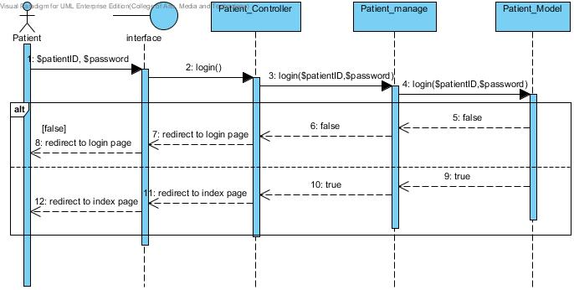
Patient Login

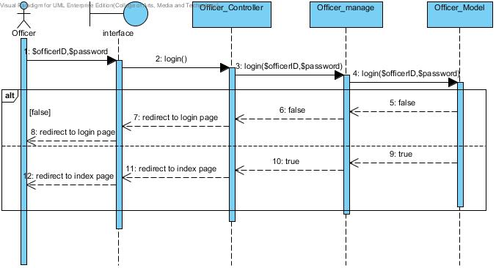

Officer Login

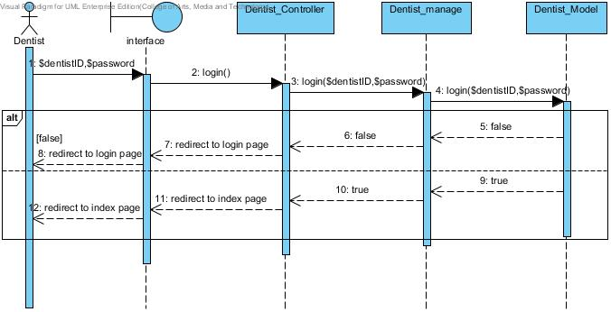

Doctor login
Logout
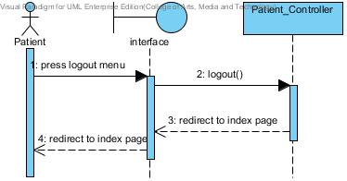

Patient logout

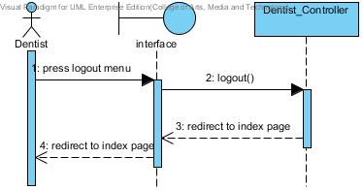

Officer logout

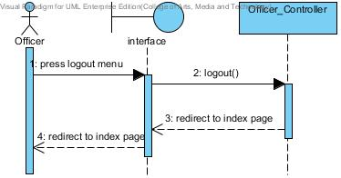

Figure 10: Doctor Logout
View doctor clinic calendar
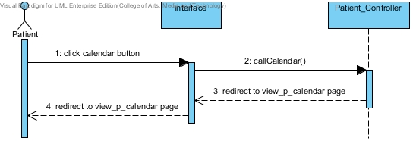

Patient view doctor clinic calendar

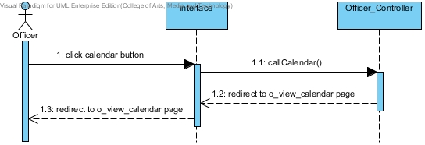

Officer view doctor calendar

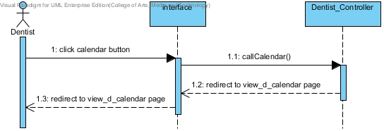

Dentist view calendar
View his/her own appointment
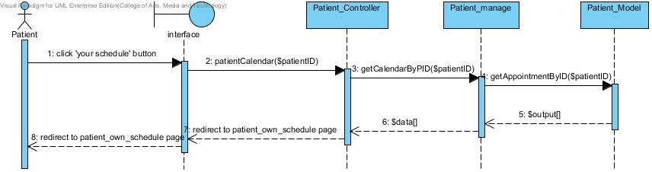
Figure 14: Patient can view his/her own appointment

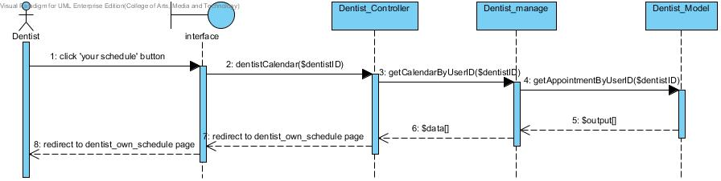
View all appointment in doctor clinic
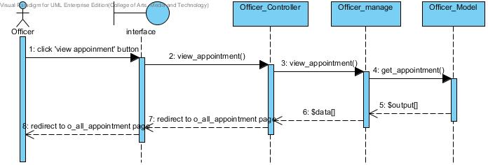

Officer can view all appointment in hospital

Create patient account

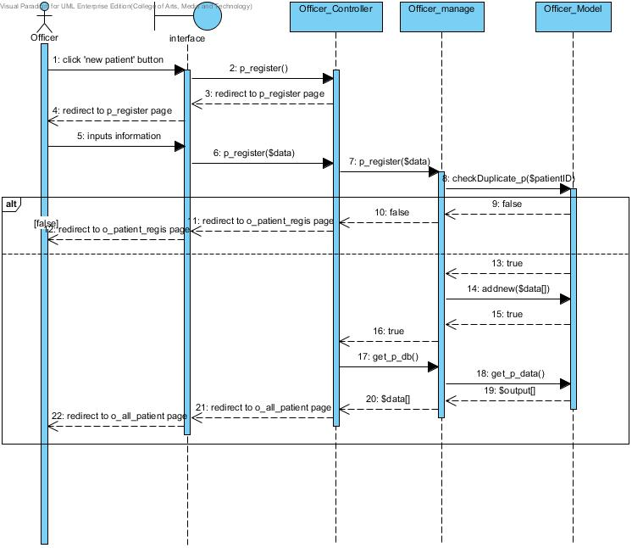
Officer can create new patient account and the list of all patients show after register

Use Case Diagram

Clinic services system Use Case for Patient

Patient and Visitor

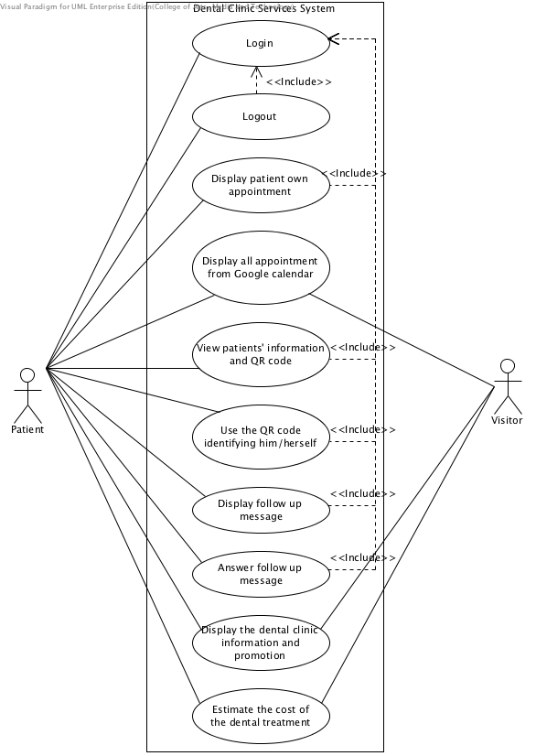

Figure: Dental clinic services system patient use case diagram

Clinic services system Use Case for Officer
Officer
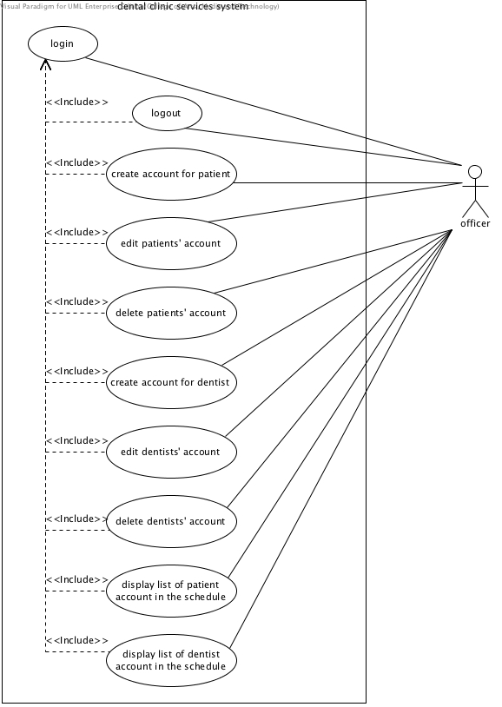
Clinic services system officer use case diagram
(Account management)

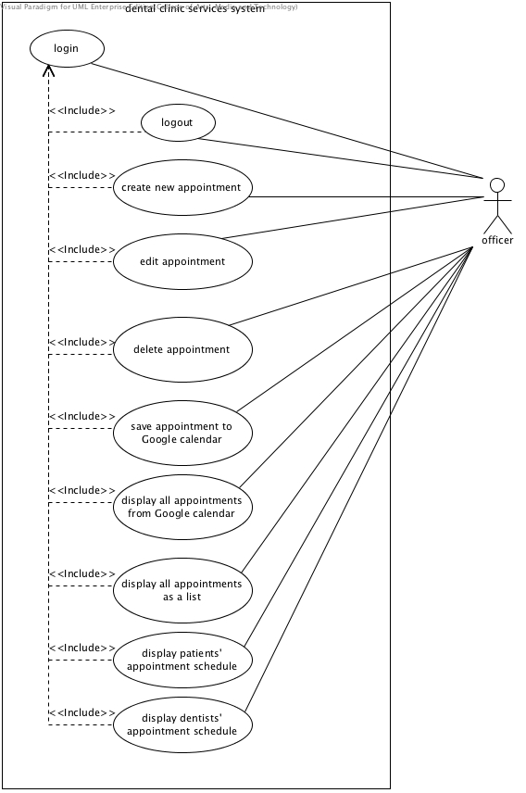

Figure: Clinic services system officer use case diagram
(Appointment management)

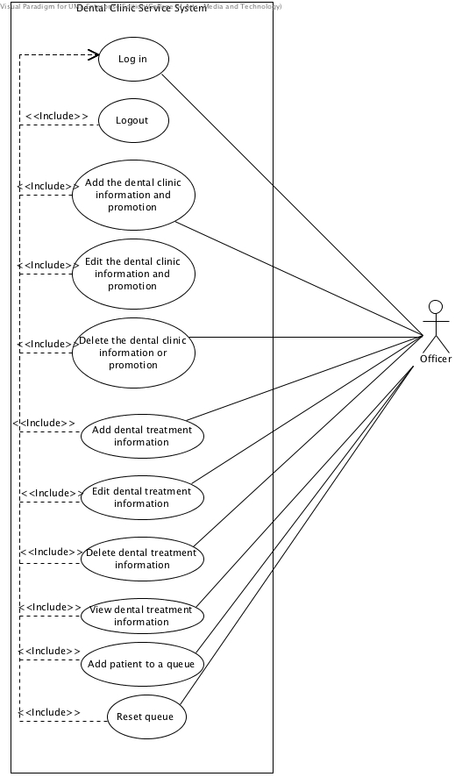

Figure: Dental clinic services system officer use case diagram

User Interface Design
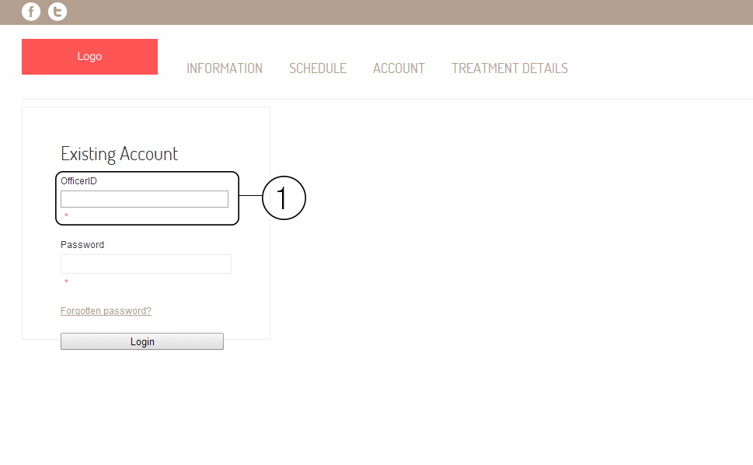
Login.
Shows the login page of the website. The area number 1 is the field of input userID and patientID. In officer login page will show as OfficerID, in patient login page will show as PatientID, and in dentist login page will show as DoctorID
Create a new User.
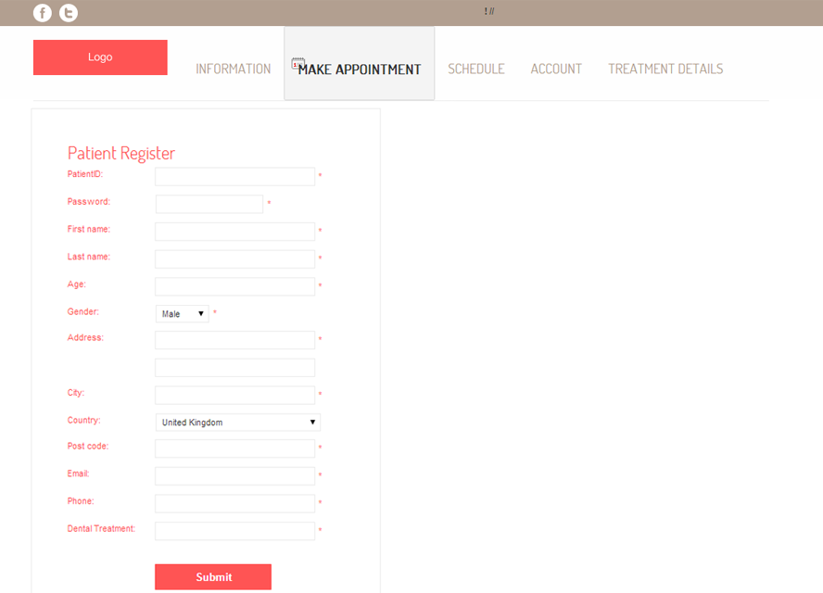

Edit User Details

